PLANETARIUM QUESTIONS
(Total Duration: 15 minutes)
Please pay attention to the North direction marked in the answer sheets.
- The projected image in the planetarium is a simulated image of the Magelang sky forJuly 28, 2015 at 21.00 (UTC+7). There are three stars missing in the image. Please mark the position of the three missing bright stars in Answer Sheet 1 by a cross (x) and write their namesbeside the cross marks using their IAU designations. For guidance you can also include a few stars that you see in the planetarium and mark them with circles (o). The list of the bright stars which possibly missing are attached.(Duration: 6 minutes)(60 points)
- Assume that a bright supernova appears in the sky on September 24, 2015 and you watch it at 22.00 (UTC+7). The planetarium will now show the sky for this date with the supernova. Mark the position of the supernova by a cross (x) in AnswerSheet 2. You can mark other stars by circle (o) for guidance. (Duration: 3 minutes)(50 points)
- The planetarium will now display the Magelang sky for January 3, 2016, at23.00 (UTC+7). The examiner will point to a star with an arrow. Estimate the times at which this star will rise and set from Magelang on this date up to 20 minutes accuracy. (Duration: 6 minutes)(40 points)

ANSWER SHEET 1
Answer of question 1:
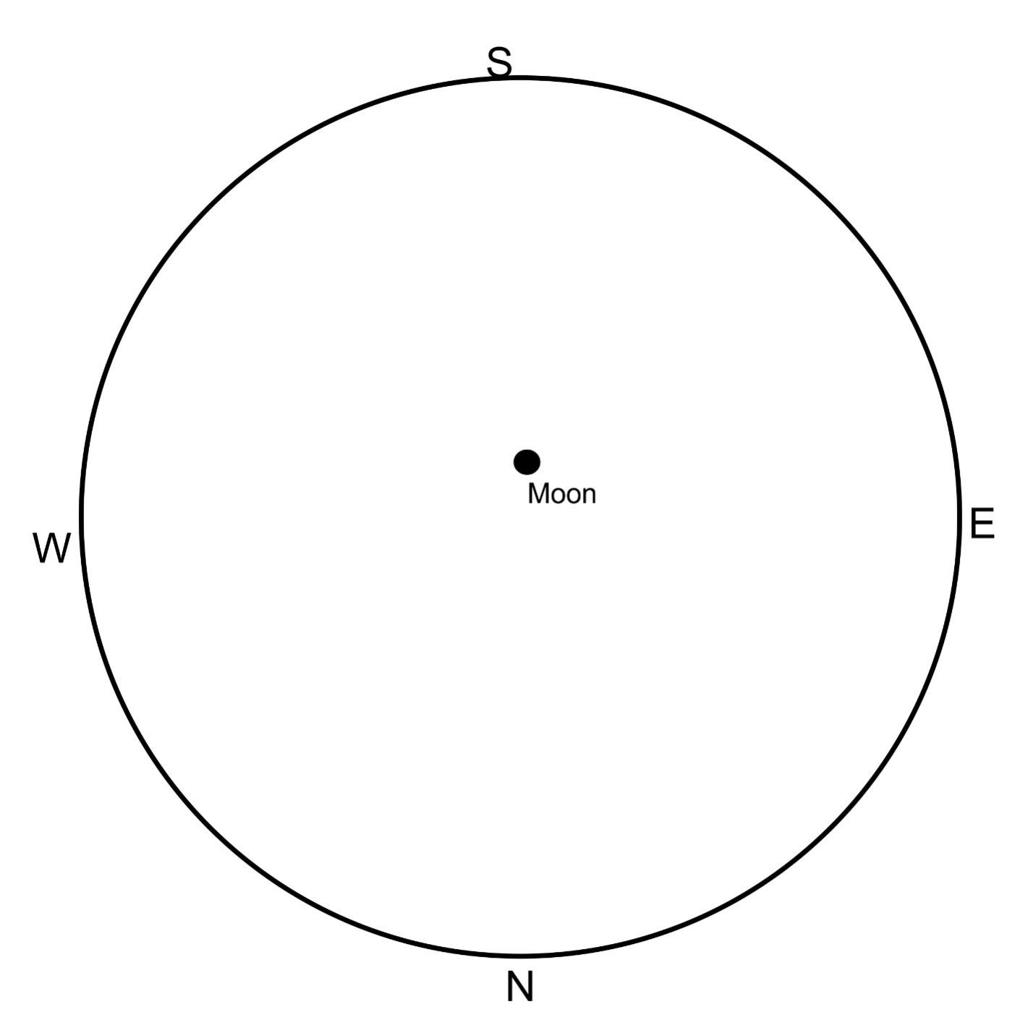

Note: the circumference indicates the horizon.
α Pav | α Lyr | α Aql
α Vir | α CrB | α Gru
α Ser | α Cen | α Cyg
α Oph | α Cru | α Boo
α PsA | α Sco | β Aqr
β Cru | β Oph | β Peg
$γ$ Sco | $γ$ Cyg | $δ$ Pav
$ε$ Peg | $ε$ Boo

ANSWER SHEET 2
Answer of question 2
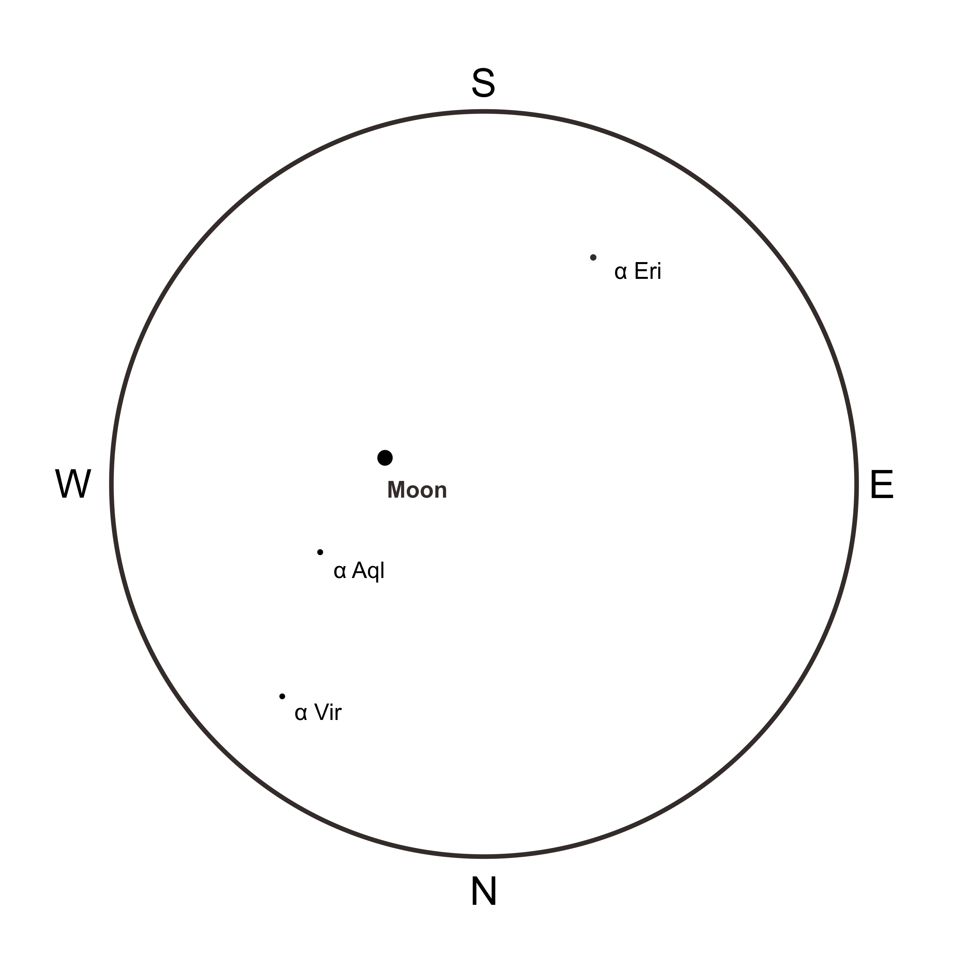Answer of Question 3:
Rise time:
Set time:

